**Step 1: Set up the React App**

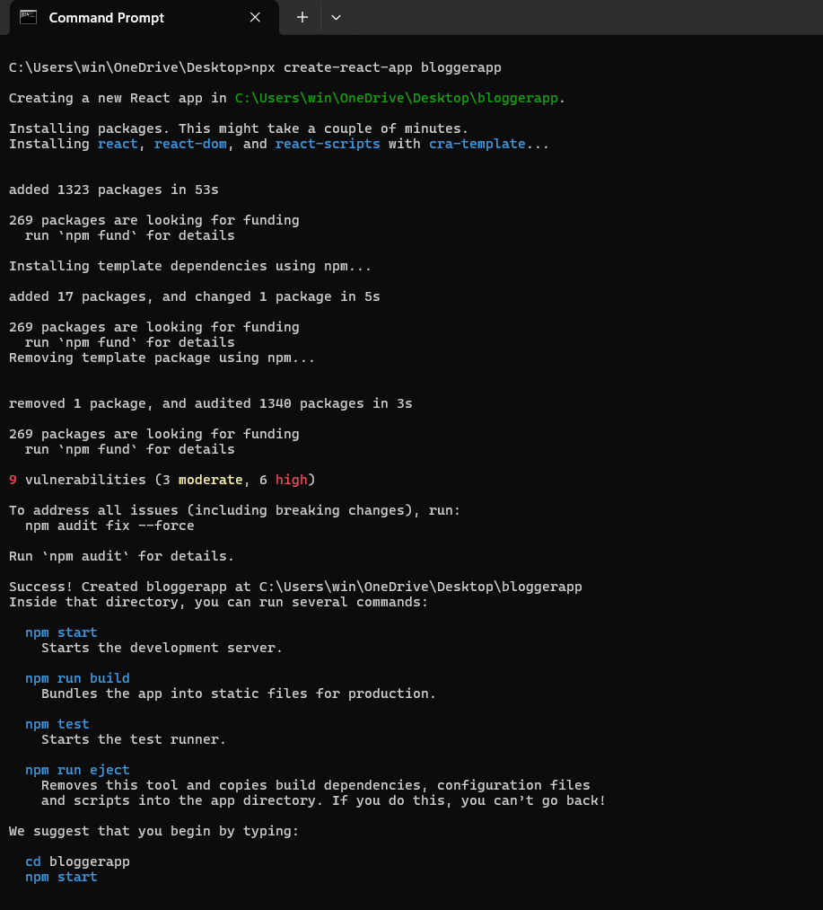

**Step 2:** Create Components

Create a new folder: src/components/

Inside that folder, create 3 files:

**BookDetails.js**

import React from 'react';

const BookDetails = () => {

  return <h2>This is Book Details</h2>;

};

export default BookDetails;

**BlogDetails.js**

import React from 'react';

const BlogDetails = () => {

  return <h2>This is Blog Details</h2>;

};

export default BlogDetails;

**CourseDetails.js**

import React from 'react';

const CourseDetails = () => {

  return <h2>This is Course Details</h2>;

};

export default CourseDetails;

**Step 3**: Create book.js (src/data/book.js)

export const books = [

  { id: 101, bname: 'Master React', price: 670 },

  { id: 102, bname: 'Deep Dive into Angular 11', price: 800 },

  { id: 103, bname: 'Mongo Essentials', price: 450 },

];

**Step 4:** Update App.js

import React, { useState } from 'react';

import { books } from './data/book';

import './App.css';

function App() {

  const [activeView, setActiveView] = useState('book'); // default is Book view

  const bookdet = (

    <ul>

      {books.map(book => (

        <li key={book.id}>

          {book.bname} - ₹{book.price}

        </li>

      ))}

    </ul>

  );

  const content = (

    <ul>

      <li>React vs Angular</li>

      <li>How to Write Clean Code</li>

      <li>Why TypeScript Matters</li>

    </ul>

  );

  const coursedet = (

    <ul>

      <li>Full Stack Web Dev</li>

      <li>Data Structures in JS</li>

      <li>React with Redux Toolkit</li>

    </ul>

  );

  return (

    <div className="App">

      <h1>Blogger App</h1>

      {/* BUTTONS TO CHANGE VIEWS */}

      <div style={{ marginBottom: '20px' }}>

        <button onClick={() => setActiveView('book')}>Show Book Details</button>

        <button onClick={() => setActiveView('blog')}>Show Blog Details</button>

        <button onClick={() => setActiveView('course')}>Show Course Details</button>

      </div>

      {/* 📘 CONDITIONAL RENDERING BASED ON activeView */}

      {activeView === 'book' && (

        <div className="st2">

          <h1>Book Details</h1>

          {bookdet}

        </div>

      )}

      {activeView === 'blog' && (

        <div className="v1">

          <h1>Blog Details</h1>

          {content}

        </div>

      )}

      {activeView === 'course' && (

        <div className="mystyle1">

          <h1>Course Details</h1>

          {coursedet}

        </div>

      )}

    </div>

  );

}

export default App;

**Step5**: Update App.css

.st2 {

  background-color: #f9f9f9;

  padding: 10px;

  margin: 10px;

}

.v1 {

  background-color: #e0f7fa;

  padding: 10px;

  margin: 10px;

}

.mystyle1 {

  background-color: #f3e5f5;

  padding: 10px;

  margin: 10px;

}

button {

  margin-right: 10px;

  padding: 8px 12px;

  font-weight: bold;

}

**Step 6**: Run the app

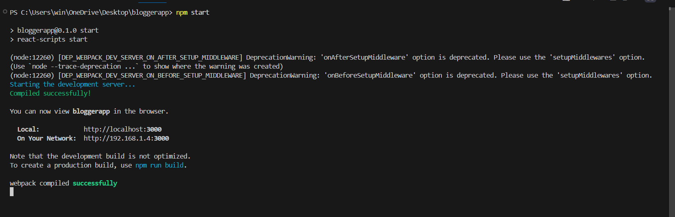

**Output:** 